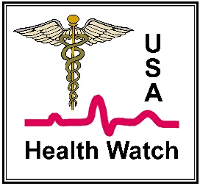
Health Watch USA^{sm} Summary of Recommendations for ACE Inhibitors and ARBs During the COVID-19 Pandemic

It is known that in many studies high-blood pressure is the highest risk factor for severe COVID-19 infections. During a recent JAMA discussion, Dr. Anthony Fauci is reported to have “wondered why someone with well-controlled hypertension would have a much greater chance of dying from COVID-19. He urged delving into this deeper and finding out which medications those individuals were taking.”(1)
A number of reports including the NIH Director’s Blog have implicated the ACE2 enzyme as the receptor for the COVID-19 Virus’s attachment and cellular entry.(2) There is concern that ACE inhibitor medications, which are used to treat hypertension, may worsen COVID-19 since research has shown they increase the ACE2 enzyme receptor. Dr. Anthony Fauci further stated: “If you look at the mechanistic rational for concern, it is there and it is firm.”
For complete references and audio clip from Dr. Anthony Fauci please go to: http://www.healthwatchusa.org/COVID19_ACE-Inhibitors2.htm
However, at least four major medical societies have recommended maintaining treatment recommendations of ACE Inhibitors and ARBs until more data is obtained, unless otherwise directed by the patient’s physician.(1)
Despite the lack of clinical evidence researchers from the University of Oxford and University of Birmingham in the United Kingdom have formulated recommendations regarding ACE Inhibitors and Angiotensin Receptor Antagonists (ARBs) for those who have developed COVID-19 and for those at high risk of contracting an infection.(3) Their recommendations are as follows:

1. “Many patients with mild diabetes or cardiovascular disease or both will be taking these medicines for their long-term benefits; withdrawing treatment during an acute infection will cause little harm and is reasonable.”
2. “Those who are deriving marginal benefit from these medicines, but who are at a high risk of infection because of exposure (e.g. younger healthcare workers) may reasonably stop taking these medicines during the epidemic; the adverse effects of drug withdrawal will be small and the risks of continuing therapy before and especially during an infection, albeit not quantified, may be greater.”
3. “On recovery from the infection, treatment should be continued or resumed, as appropriate.”
4. “This advice, summarized in the Figure, is based on the theoretical considerations outlined above; it should be reviewed when the results of data mining patient records or clinical trials become available.”
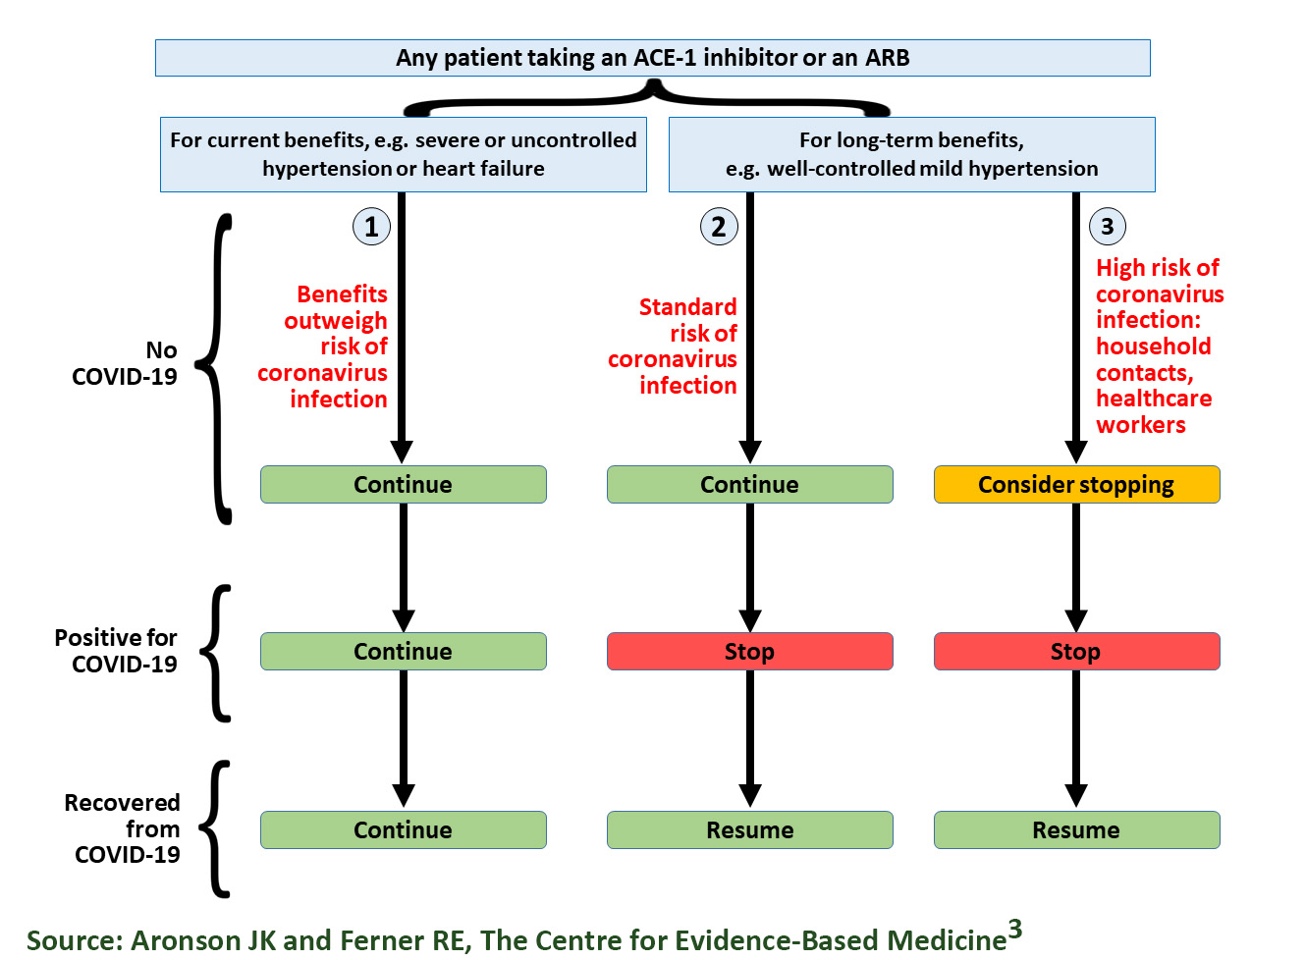
They also recommend to consider taking COVID-19 negative patients off of ACE Inhibitors or ARBs if there is an increased risk of COVID-19 Virus infection.
In the current environment of reduced access to healthcare, those at home and on ACE Inhibitors or ARBs should NOT try to withdraw from them without medical supervision and consultation with their doctor. Switching medical treatments can be difficult and rebound hypertension may occur. In addition, there may be an increased risk of stroke or heart disease.
However, there are two additional caveats which we feel should be considered by healthcare providers until this controversy is settled:
1. All hypertensive patients on ACE Inhibitors or ARBs should be counseled regarding strict isolation and social distancing. Especially patients who are taking these drugs for long-term benefit, e.g. those with severe heart failure or hypertension, because of the risk that their condition will worsen if they stop taking them and such individuals are also likely to be vulnerable to severe disease if they acquire the COVID-19 virus.
2. During this epidemic, patients should not be newly started on these medications unless they are required for serious health conditions and there are no safe alternatives.
Patients should always consult their physician for recommendations regarding their care. Changing medication that treats high blood pressure or heart failure can be a complicated process and should never be attempted without professional guidance. It is also important to weigh the risk and benefits depending on the prevalence of the COVID-19 virus in your area and your comorbidities for a severe COVID-19 disease.
References http://www.healthwatchusa.org/COVID19_ACE-Inhibitors2.htm
- Fryhofer, SA. Antihypertensive Drugs During COVID-10: Still Up in the Air. Medscape. April 10, 2020. https://www.medscape.com/viewarticle/928099 Source Audio: https://edhub.ama-assn.org/jn-learning/audio-player/18324686
- Sheridan K. The coronavirus sneaks into cells through a key receptor. Could targeting it lead to a treatment? Stat. April 10, 2020. https://www.statnews.com/2020/04/10/coronavirus-ace-2-receptor/ Source Research: https://www.cell.com/cell/pdf/S0092-8674(20)30229-4.pdf
- Aronson JK and Ferner RE. ACE Inhibitors and Angiotensin Receptor Blockers (ARBVs) in COVID-19? https://www.cebm.net/covid-19/angiotensin-converting-enzyme-ace-inhibitors-and-angiotensin-receptor-blockers-in-covid-19/

